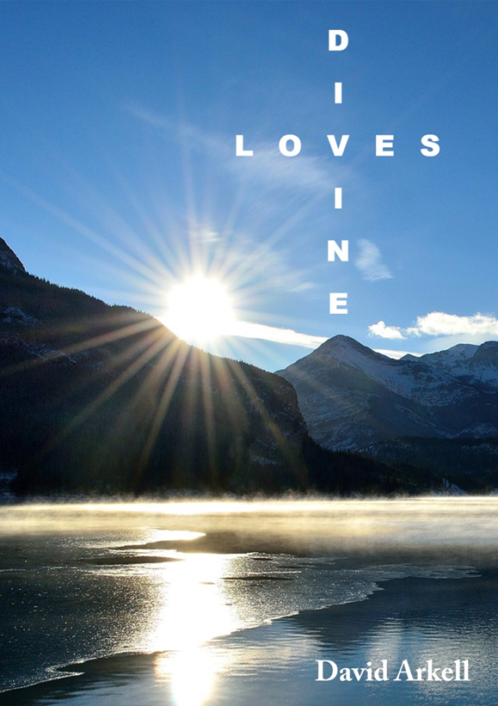

D
I
L O V E S
I
N
E

A Medley Of Lyric Musings

David Arkell

Spacious Salvation

Spirit of the Sovereign Lord
Anointing with His lavish grace,
Magnified by all, adored;
Reaching out in wide embrace,

Healing lives in turmoil, broken,
Setting captives loose from chain.¹
Good news to the poor is spoken,
Sight recovered prisoners gain.

Tender gaze, compassion’s tears
Long to cure the wounds of old,
Restore the barren locust years;²
Let a story fresh be told:

Confidence and faith renewed,
Change transforming deep within,
Stamina by God imbued,
Battles of the Lord to win.³

Grounded in the living Word,⁴
Armed to tackle each temptation;
Never forsaken,⁵ undeterred,
Helmet worn of firm salvation.⁶

Pillowed soft on waves of love;
Not bestowed with ashes grey,
But beauty’s crown from high above,
As night concedes to dawning day.

1. Psalm 107.14
2. Joel 2.25
3. 2 Chronicles 20.15
4. Colossians 2.7
5. Deuteronomy 31.8
6. Ephesians 6.17

Oil of gladness flowing free,
Clouds dispersed in mourning’s grief;
Garment of praise in harmony
Lifting souls, despair to relief.

Sturdy, tall, strong they stand,
Rooted fast with gentle sway;
Nurtured by the Father’s hand,
Nourished daily as they pray –

Mighty oaks of righteousness
Planted by the Lord, Whose way
Of truth and life⁷ vivacious⁸
Splendid glory shall display.

Dedicate the heart’s desire,
Seek and strive above all things;⁹
Nothing else can e’er be higher –
Christ exalted, King of kings.¹⁰

7. John 14.6
8. John 10.10
9. Isaiah 26.8; Psalm 37.4-5
10. Revelation 19.16

Inspired by Isaiah 61.1-3.

Pilgrim

Wondering where it may be found –
Space we long to call a home;
Nest in which the self unbound
Truly feels its essence own.

Searching often far and wide,
Ceaseless quest for restful dell;
Put the bitter trials aside,
Calm the soul’s disturbing well,

Seek the stillness of the core,
Inner sanctum’s deep tranquillity;
Learn to shut the outer door
Barring shallow superfluity.

Striding up to giddy heights,
Mountain peak and coastal scene –
Preview of celestial sights,
Frisson pure, vista serene;

Beauty on such stunning scale,
This could be Elysium’s field,
Were it not for human wail,
Cleaving sword of conflict’s wield.

Here we have no resting place,¹
Just a worldly passing-through;
Fragile body, name and face
Closely known by precious few.

Never fully comprehended,
Lonely in the secret parts;
Wanting needs left unattended,
Minds unblossomed, broken hearts.

Looking for the real abode,
Where that lies who can say?
Wandering nomad on the road,
Find this jewel’s glinting ray.

Selah

Way and Truth,² living Word,³
He for us the journey made,
Resolute and undeterred.⁴
Firm foundation, readied, laid,

Splendid mansion, rooms profuse
Primed for us His offspring.⁵
Coming home from toil and bruise,⁶
Welcomed by the Father-King;

Folded in His warm embrace,
Final dwelling, land secure;
Life eternal,⁷ house of grace,
Peace surpassing ever sure.⁸

1. Hebrews 13.14
2. John 14.6
3. John 1.1-4, 14
4. Hebrews 12.2
5. John 1.12-13; 1 John 3.1
6. John 14.2-3
7. John 3.16
8. Philippians 4.7

River

Softly moving on his course,
Depth obscure whose progress knows
Steady pull of currents’ force,
Through the rolling meadow flows;

Onwards to the distant end,
Destiny as yet unseen.
Channels straight, many a bend,
Banks to hug the watery sheen.

Swirling eddies playfully spin
Restless in mercurial flux;
Lightly on the surface skim
Looking in towards the crux.

Rapids shallow bubbling along
Chattering merrily on their way.
Soon a place of different song
Heard in tones of mellow sway.

Movement slowed, hovering hush,
Silence of the deepness calm;
Scarce a breeze to stir the rush,
Time held still in tranquil balm.

Lilting reeds in elegant dance,
Charmed by lilies’ demure repose.
Foliage floats with nonchalance,
Lazily drifts in peaceful doze.

Weeping willow sheds her tears,
Drooping bent her body leans;
Wistfulness of many years
Mirrored in the fluid seams,

Glinting 'neath her arching boughs,
Sunlight’s quiver speckling leaves;
Tandem ripples gently rouse
Silvery shimmer of fleeting weaves.

Slender trunk, yet strong within,
Roots embedded reaching down.
Creatures of earth and birds on wing
Shelter in her canopy’s gown.

Fount of life in welling burst
Watering every inmost need,¹
Satisfying driest thirst;²
Springs of goodness pure exceed,

Overflowing grace outpoured,³
Mercy’s gift that none may perish;⁴
Healing stream from heaven’s Lord,⁵
Ours the choice His love to cherish.

1. Philippians 4.19
2. John 4.13-14
3. Romans 5.15
4. 2 Peter 3.9
5. Revelation 22.1-2

Inspired by the view below of the River Rib at Latchford, Hertfordshire.

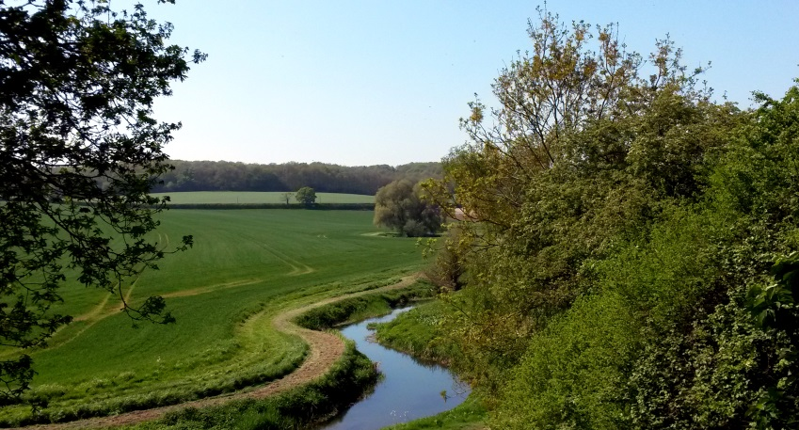

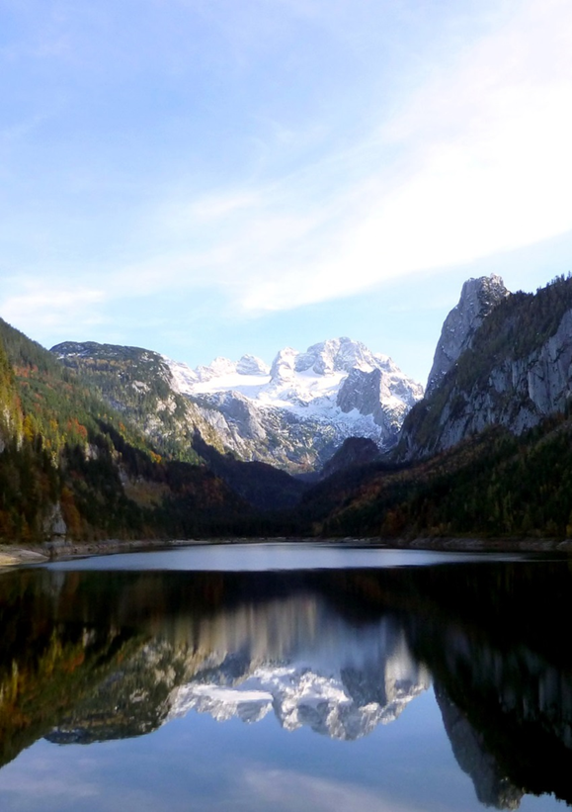
These poems reflect the heart of a poet who loves God and sees His presence and glory in the ordinary and extraordinary. This strand of deep faith runs throughout. There are poems to make us laugh or cry. Poems which observe and illustrate the wonder and beauty of our world, and some which examine human suffering. Poems that offer hope in the darkness. Poems which, like the Psalms, express the depth of the human heart seeking to find a way through life and make sense of it. This many-hued collection invites us on a journey to a place of peace, a place of praise and awe, a place of trust in the God Who knows and loves us.
Reverend Amanda Duncan,
Vicar of the Benefices of High Cross and Thundridge, Hertfordshire

All proceeds from this book will go to supporting the work of the Bible Society. For more information please visit the website: www.biblesociety.org.uk

£5.00 (£6.50 including post and packaging) available from David Arkell at davidharkell@yahoo.co.uk

